**Karkhana.io Assignment**   
  
 **CODE:**   
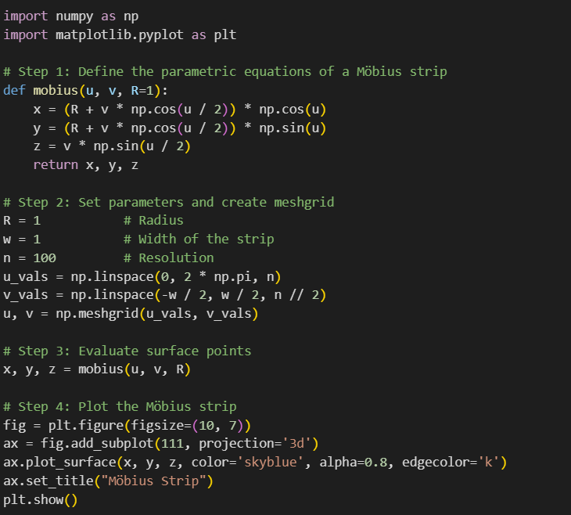  
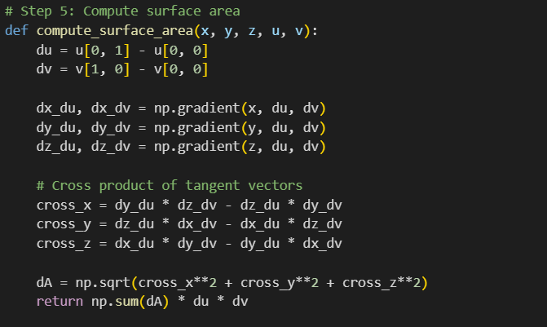  
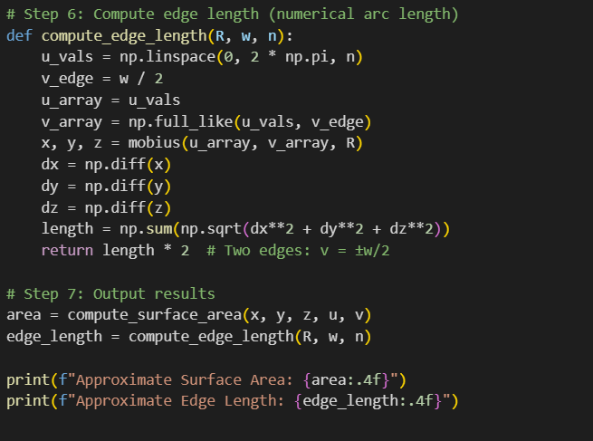  
Output: (3D Plot Screenshot, Surface area, Edge Length)  
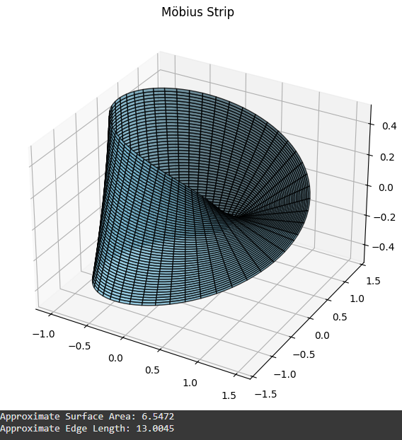  
  
  
**THEORY PART:**  
  
**1. How I structured the code (Explained Simply**)

I broke the code into simple steps so that each part does one clear thing:

**Step 1: Define the Möbius strip**

I started by writing a function that describes the Möbius strip using math formulas (parametric equations). This tells Python how to create the shape in 3D space.

**Step 2: Create the grid**

Next, I made a grid of u and v values. Think of these as coordinates that help define every point on the surface of the strip.

**Step 3: Calculate 3D points**

Using that grid, I calculated the 3D positions (x, y, z) for every point on the strip.

**Step 4: Plot the strip**

Then, I used Matplotlib to draw the Möbius strip in 3D. This helped me check if the shape looked right.

**Step 5: Estimate the surface area**

I wrote a function that calculates an approximate surface area. It uses gradients and vector math (cross product) to figure out the area of tiny pieces, and then adds them all up.

**Step 6: Calculate the edge length**

I added another function to find the total length of the strip’s edges by calculating the distance along its boundary.

**Step 7: Show the results**

Finally, I printed the surface area and edge length so I could see the final values.  
  
  
  
**2. How I approximated the surface area**

To find the surface area of the Möbius strip, I used a method that breaks the surface into lots of tiny pieces and adds them up. Here's how I did it:

**Step 1: See how the surface changes**

I used a function called np.gradient to see how the shape changes in two directions. It’s like checking how the surface tilts or curves as you move along it.

**Step 2: Find tiny surface pieces**

Then, I used a bit of math (called the cross product) to figure out the shape and size of each little piece of the surface.

**Step 3: Measure each piece**

I measured how big each tiny piece is by taking the length of the result from the cross product. This tells me the area of that small patch.

**Step 4: Add everything together**

Finally, I added up all those little areas to get the total surface area of the strip. I also multiplied by how far apart the points on the grid are to make the result accurate.  
  
  
  
**3. Any challenges I faced**

While working on this project, I ran into a few challenges:

**\*Understanding the math**

At first, it was a bit tricky to understand how to write the parametric equations for the Möbius strip correctly. Since the shape has a twist, it took some time to get it right.

**\*Working with gradients and vectors**

Figuring out how to calculate the surface area using gradients and cross products was confusing at first. I had to be careful with how I used np.gradient to make sure I was doing it the right way.